**Example Input:**

**Sample_input.csv:**Passed some sample observations to test(40 customers)

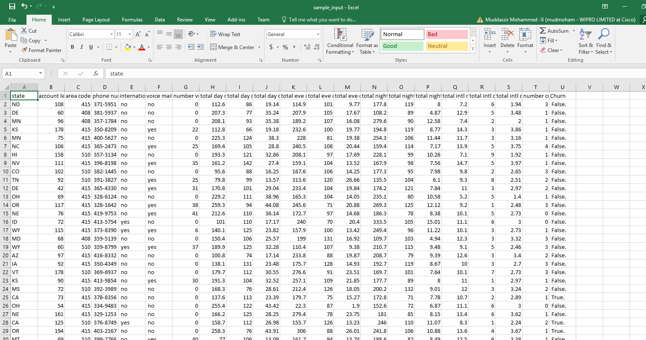

**Python Output:**

**py_sample_output.csv**

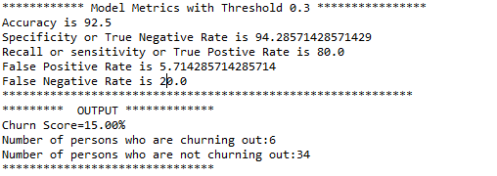

**R Output:**

**R_sample_output.csv**

